Modelling High Temperature Subsurface Energy Storage using Dynamic Mesh Optimisation
Dr Pablo Salinas, Dr Carl Jacquemyn and Professor Matthew Jackson
Novel Reservoir Modelling and Simulation Group, Department of Earth Science and Engineering

The main objective of this project is to study the potential of High-Temperature Subsurface Energy Storage using the open-source Imperial College Finite Element Reservoir Simulator (IC-FERST). IC-FERST incorporates state-of-the-art technology for porous media flow simulation, including unstructured dynamic mesh optimisation (DMO), high order element methods and a surface-based representation of complex reservoir architecture. Geological representation for IC-FERST uses a surface-based modelling approach in which all heterogeneity is represented by its bounding surfaces, free from a grid.
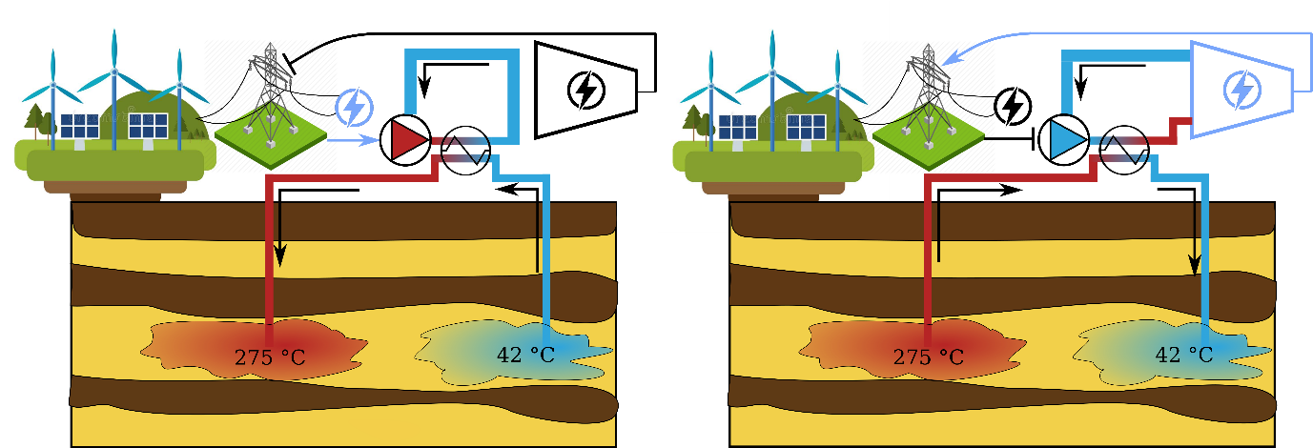
High Temperature Subsurface Energy Storage (HT-STES) offers the potential to store large quantities of energy for electricity generation with variable storage time, providing an energy buffer for weather-based renewable energy systems such as wind and solar. HT-STES works by storing the excess energy as High Temperature Water (HTW, with temperatures of 100-300ºC) in the subsurface when there is excess renewable energy production (Fig. 1). The stored HTW is pumped to surface and used to generate electricity when demand exceeds renewable supply. The cool water from this process is also stored in the subsurface and is reused, thus minimizing energy loss. HTW could be stored in aquifers, or in depleted oil or gas reservoirs, repurposing existing infrastructure.
Figure 1 Schematic representation of a HT-ATES system. When there is high electricity production, the energy is stored as HTW (left): cool water is pumped from the cold well (blue), heated and injected via the hot well (red). When required (right), the HTW is pumped back to surface via the hot well and used to generate electricity; the resulting cool water is injected via the cold well.
In this PhD project we will focus in analysing the HT-SES approach to better study its behaviour. Some of the key points to study are: i) storage efficiency of HT-SES for different geological scenarios, ii) storage mechanisms and storage optimisation, iii) plume migration, and iv) dissolution/precipitation induced by the cycling of high-temperature water.
Applicants should have a good degree in an appropriate subject (e.g. earth science, physics, mathematics, or engineering) and a strong interest in computational modelling. The project is hosted by the highly successful NOvel Reservoir Modelling and Simulation (NORMS) group and will involve extensive interactions with other research groups within the ESE department and internationally. Skills developed during this project will include multiphase porous media flows, high performance computing, CAD modelling, geological modelling, linear and non-linear solvers, dynamic mesh optimisation techniques and unstructured meshing technologies. The successful candidate will be encouraged and supported to develop their career and profile, including presenting at conferences and publishing journal articles.
For more information, please contact Dr Pablo Salinas (pablo.salinas@imperial.ac.uk) or Prof Matthew D. Jackson (m.d.jackson@imperial.ac.uk)

