Geological representation of highly heterogeneous reservoirs and aquifers using NURBS and dynamic mesh optimisation
Dr Pablo Salinas, Dr Carl Jacquemyn, Professor Chris Pain, Professor Matthew Jackson
Novel Reservoir Modelling and Simulation Group, Department of Earth Science and Engineering
This project will focus on the development of a method to generate realistic models that conform to a given geological representation based on a reference generated using CAD modelling, without prior discretisation. The approach speeds up model generation as well as allowing the geological precision to be adjusted based on flow behaviour. This project will be developed within the context of the open-source Imperial College Finite Element Reservoir Simulator (IC-FERST). IC-FERST incorporates state-of-the-art technology for porous media flow simulation, including unstructured dynamic mesh optimisation (DMO), high order element methods and surface-based representation of complex reservoir architecture. Applications of IC-FERST are numerous and include simulation of CO₂ sequestration, hydrocarbon recovery, groundwater flow, contaminant transport, geothermal and magma flow.
The geological representation for IC-FERST uses a surface-based modelling approach in which all heterogeneity is represented by its bounding surfaces, free from an underlying grid or mesh. These surfaces are created based on meaningful geological information identified a priori. This approach limits flexibility for the mesh generation as all the modelled geology must be respected by the mesh, making it challenging in some cases to generate a mesh. The generation of conforming geological meshes has been extensively studied for complex geological models and it remains a very difficult challenge due to the many length-scales to be considered. However, in some cases, all length scales might be important while in others some may be safely ignored, but this geological precision is not known before running a flow simulation.
The objectives of this PhD are twofold: (i) enable the generation of complex geological models based on surface-based modelling by developing a robust approach based on DMO and blueprints that allows the user to adjust the geological precision during a simulation, and (ii) study the impact of dynamically changing the geological precision on the accuracy of the results and potential speed up.
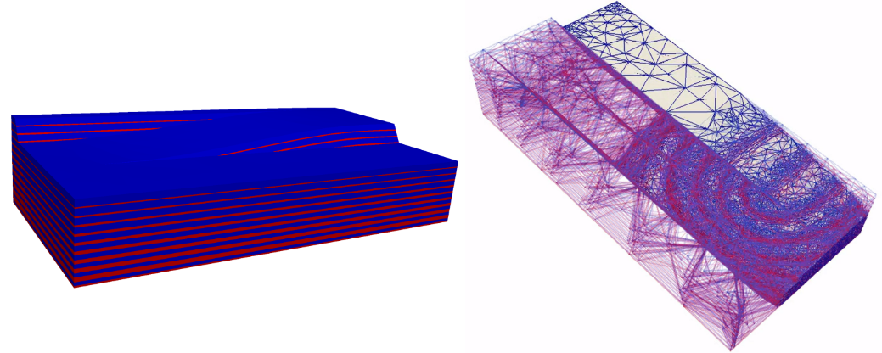
Fig. 1: Left: meshless heterogeneity blueprint coloured by permeability (red: high; blue: low) representing a relay ramp in a layered reservoir. Right: IC-FERST flow simulation showing optimized mesh of varying resolution coloured by wetting-phase saturation (red: high; blue: low).
Applicants should have a good degree in an appropriate subject (e.g. earth science, physics, mathematics or engineering) and a strong interest in computational modelling. The project is hosted by the highly successful NOvel Reservoir Modelling and Simulation (NORMS) group and will involve extensive interactions with other research groups within the ESE department and internationally. Skills developed during this project will include multiphase porous media flows, high performance computing, CAD modelling, geological modelling, linear and non-linear solvers, dynamic mesh optimisation techniques and unstructured meshing technologies. The successful candidate will be encouraged and supported to develop their career and profile, including presenting at conferences and publishing journal articles.
For more information, please contact Pablo Salinas (pablo.salinas@imperial.ac.uk).

