IMPERIAL COLLEGE

ADDING NEW EXTERNAL INTERESTS

FOR APPROVAL

Table of Contents:
Adding a new External Interests for approval.…………….………………………………3

Adding new External Interests for approval:
- Log into ICIS Self Service by entering your college username and password.

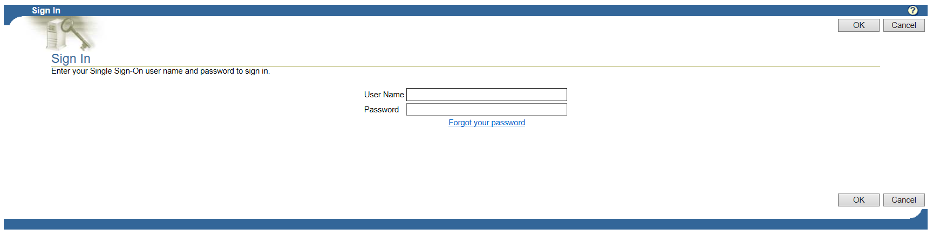

- From the Main Menu by pressing on the  to open up My Details folder and click on Annual Declarations

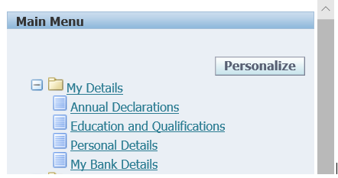

- To add a new interest, click on the Add new button highlighted below:

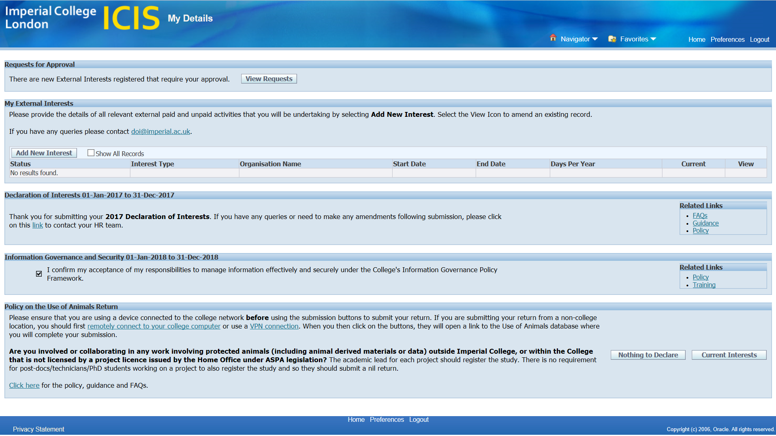

- The system will auto populate the Name, Department and Approver.

However, staff with a secondary role/s will be required to select the relevant Department the Interests is related to.

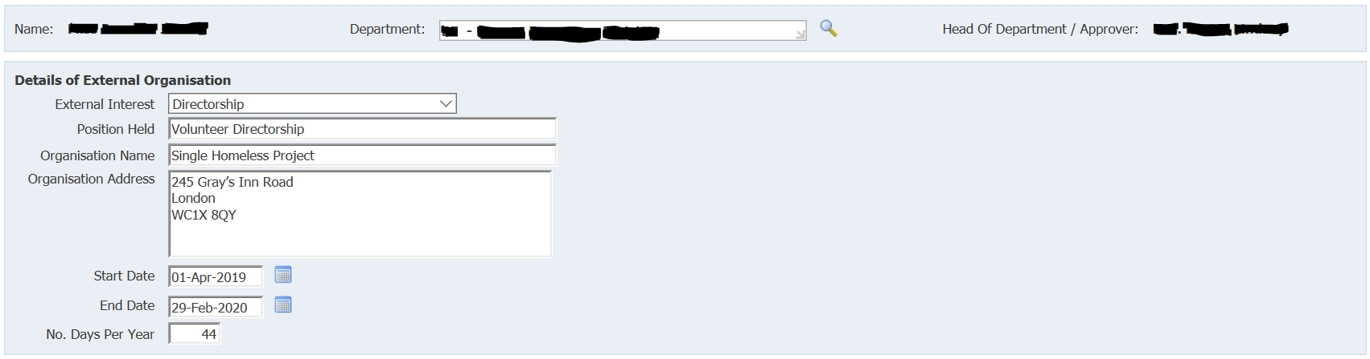

To amend the department choice allocated use the magnifying glassto open a search page.

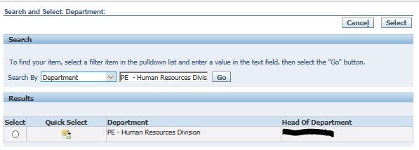

Click on action icon 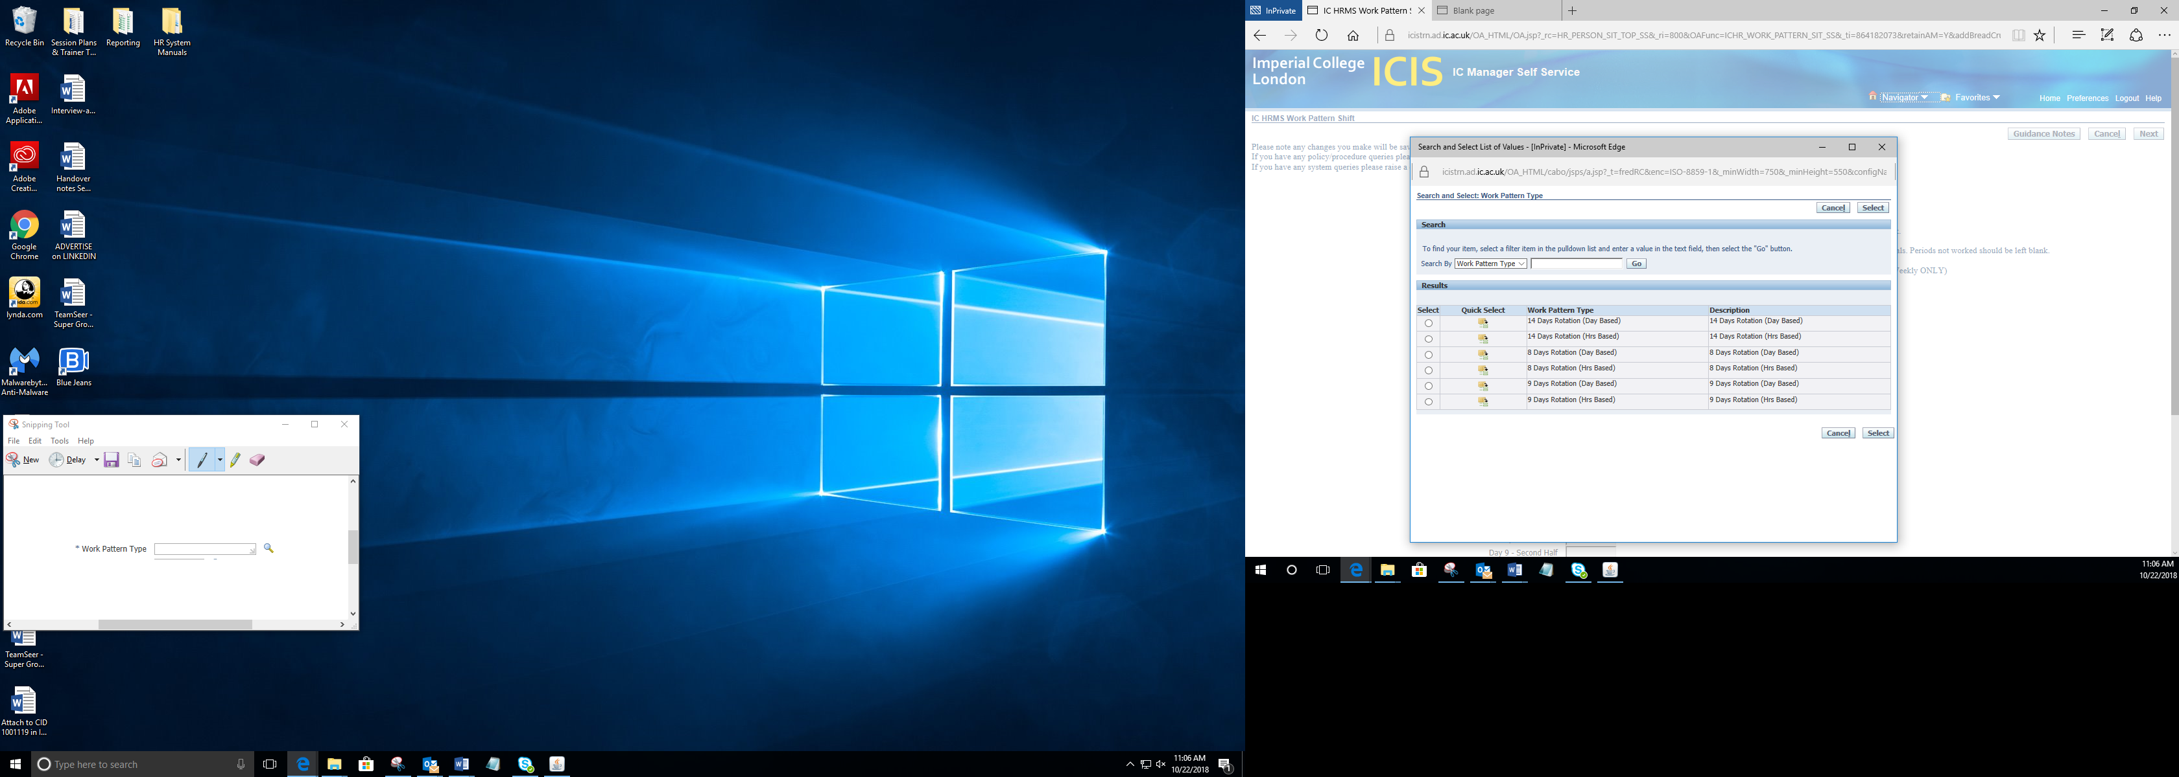 in the column labelled Quick Selection to pull through the specific department.

- Select the appropriate Interest Type from the picklist e.g. Directorship.

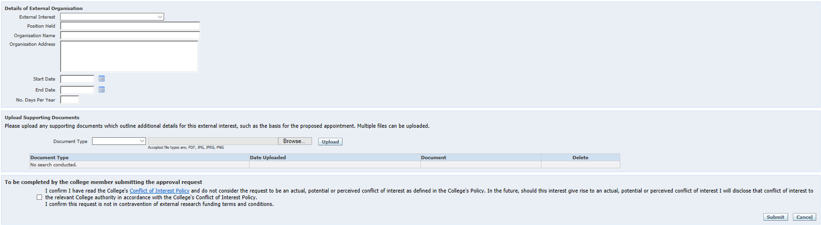

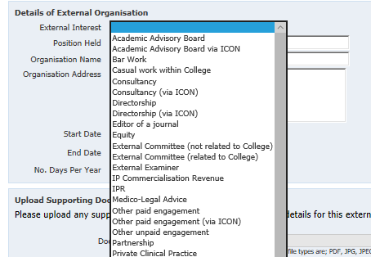
- Complete the remaining fields as shown below:

- Upload Supporting Documents
- Select from the drop down menu the type of document being uploaded
- Select browse to find and attach the corresponding document
- Press upload

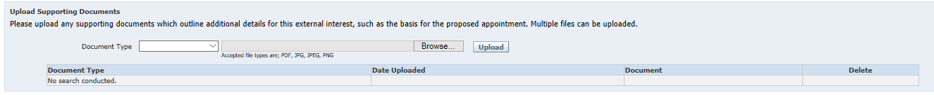

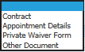

Note: Any number of relevant documents can be uploaded against each document type.

A number of External Interests will require a Private Waiver to be signed and uploaded within the supporting documents.

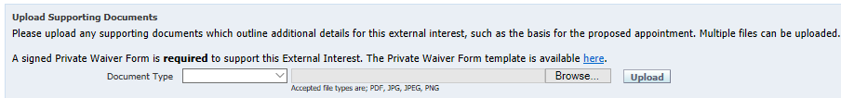

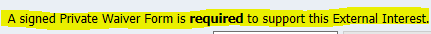

All External Interests requiring this waiver will have the above sentence highlighted in yellow along with a direct link to the Private Waiver template.

Private Waivers are not required for all positions. To view a full list of positions, policies and guidance online click here.

- Complete the final field
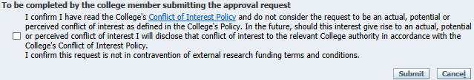
- Yes tick box
- Press Submit
Will be sent off for approval

By ticking the box you agree to have read the College's Conflict of Interest Policy and do not consider the request to be an actual, potential or perceived conflict of interest as defined in the College's Policy.

- If you have further interests to declare, click on Add another and repeat steps 3 to 7.

Note: Clicking on Cancel will return you to the homepage and will not save work currently displayed.

- To submit your declaration of Interest
Follow steps 10 to 12 from the External Interest to Declare (Self Service) guidance

Or (What is best Laura)
- Within the Annual Declaration of Interests press the Submit Declaration button

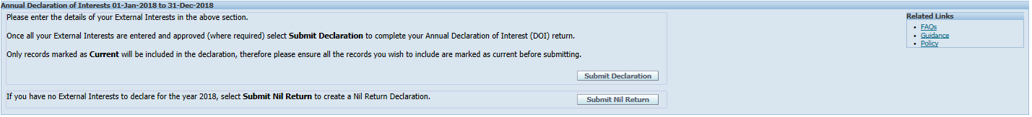

Note: In order to submit an external interest, the relevant box in the Current Interests column must be ticked.

Declaration of Interests for 2018 that are not showing can be added retrospectively for approval.

- Final submission check and once submitted no further information can be amended.

- To submit current Declarations of Interest press YES

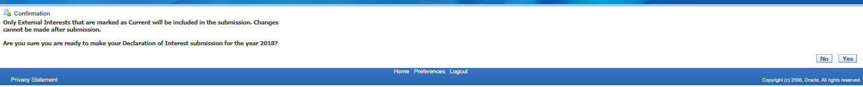

Note: Clicking on NO will return you to the homepage and without submitting the Declarations.

- Once submitted the page will automatically return back to the home screen with confirmation of your submitted 2018 Declaration of Interests

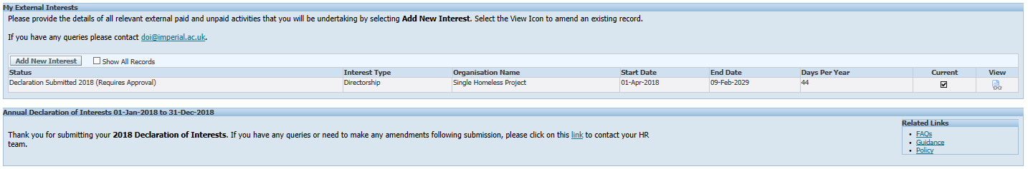

- Under Status there will be a list of all entered Declaration of Interests and once submitted for approval will say (Requires Approval)
- A confirmation message will appear, thanking you for your submission

- The Head of Department / Approver will receive a notification
- On success / rejection you will receive a confirmation email

Note: After submitting your return, you will be sent a confirmation email. If you have any queries or need to make any amendments following submission, please click on this link to contact the DOI team.

- Once submitted this will trigger off an approval request email to your Department Manager/Approver.

- If you wish to logout of ICIS after submitting your return, click on the Logout button in the top right hand corner.

Note: If you have any queries or need to make any amendments following submission, please click on this link to contact the DOI team.

Submitting External Interest using email of Interest:
Email communication will go out across the college to those required to complete the Declaration of External Interests.
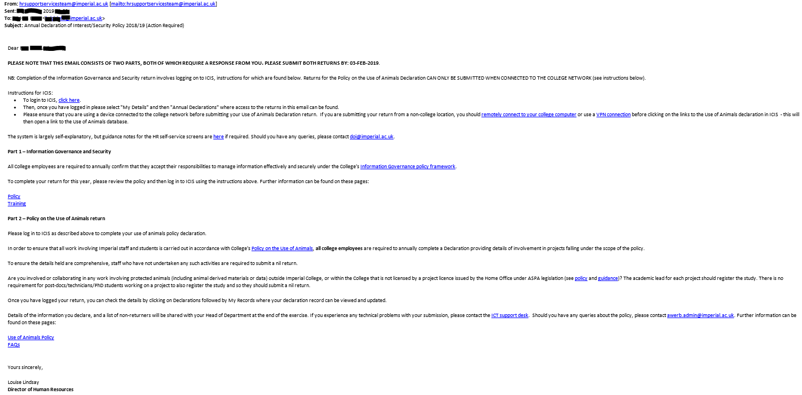

The log in link will direct you to the ICIS page and please follow steps 1 to 10.

Once submitted the page will automatically return back to the home screen with confirmation of your submitted current Declaration of Interests.

- The Status will be a list of all entered of Interests and once submitted for approval will say (Requires Approval)
- A confirmation message will appear, thanking you for your submission

- The Head of Department / Approver will receive a notification
- On success / rejection you will receive a confirmation email

After submitting your return, you will be sent a confirmation email. If you have any queries or need to make any amendments following submission, please click on this link to contact the DOI team.

